App: Tellagami

In a nutshell:
Create a talking avatar with your very own background. Exports to camera roll as a movie. Extension: Record a series of gamis and import them all into iMovie to create a longer presentation.

Lesson Ideas:
English
- Create a news report. Obtain an image from a recent news event then create a broadcast from the location reporting as an on the scene reporter.
- Create a weather report. Draw your own or obtain a weather map image. Record a news weather report.
- Present an information report e.g. Australian animal. Create your own drawings or obtain images for the background to support the information you are delivering.
- Give a book review. Feature the cover or images from the book as the background.
- Create a response to a story you’ve just read. What did you enjoy, what did you find interesting?
- Summarise the chapter of the day from one of the character's perspectives. Create a virtual person to represent the character, and then record a 30 second summary.
- Create a character description. Make a character from your story then have them describe themselves.

Maths
- Explain a Maths concept. Use your own drawings as backgrounds to support your explanation.

Science
- Explain a scientific concept.

How to Use Tellagami

- Open the app and click CREATE.
- Click on CHARACTER and then customise your character by adjusting their body and wardrobe features. 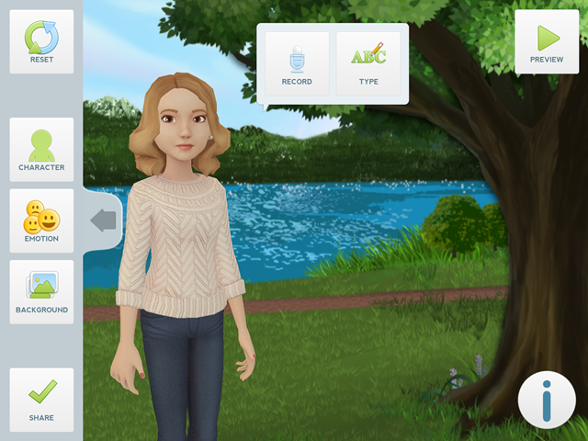 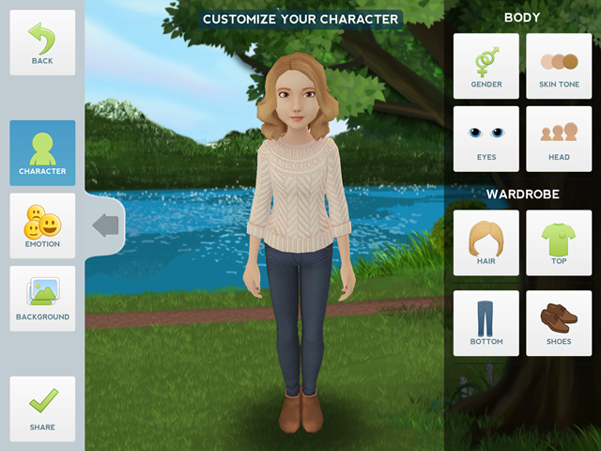
- Give your character an emotion.

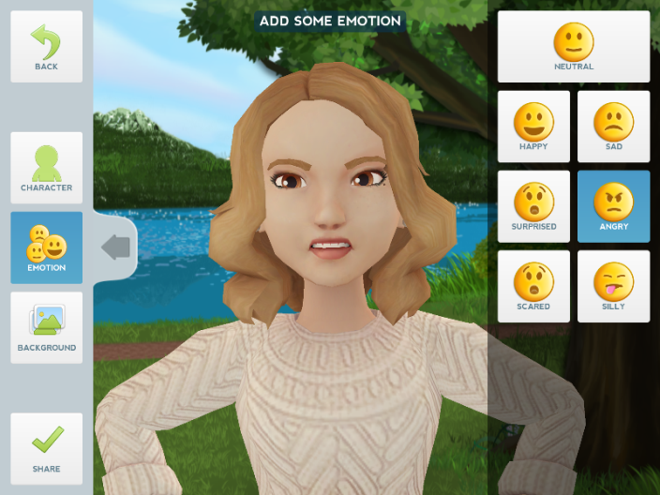

- Add a background. You can use one from your photo library or you can take a photo now using TAKE PHOTO. There are also some default ones you can use.
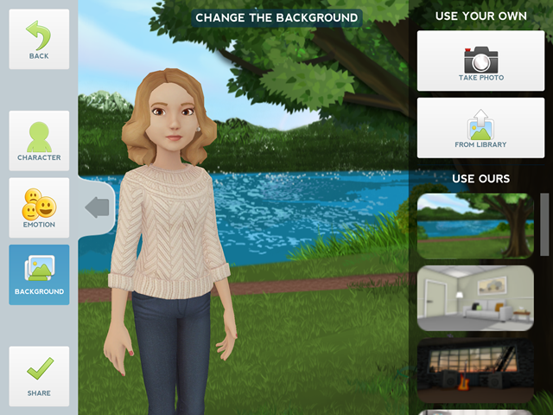
Use their default backgrounds
Choose an existing photo
Take a photo

- Click BACK to view your character and background and then to give it a voice. You can type in your message for a computerised voice, or simply record your own!

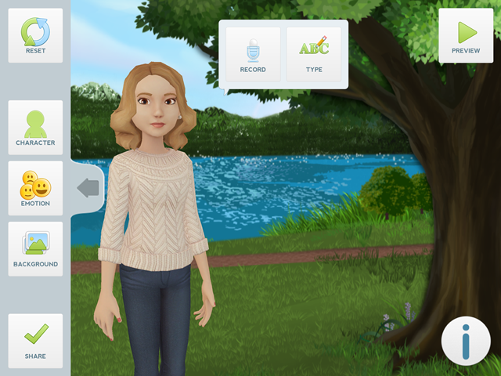

- Once completed, click on SHARE. You can then save the movie to the camera roll or email it directly to yourself (Students can email it directly to the teacher).
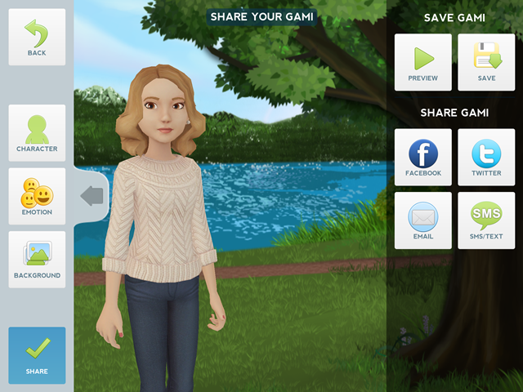
Save to photo roll

Email it to someone

© Laura Chaffey

