App: Comic Strip
In a nutshell:
Create your own comics using photographs or images saved from the internet. Add speech bubbles, action stickers and text boxes. Export to photo roll. Comic Life has basic layouts and limited stickers.

Lesson Ideas:
English
- Speech marks – Have students create a comic using speech marks, then write the conversation using direct speech.
- Onomatopoeia – Investigate the use of onomatopoeia in comics then create your own using the action stickers.
- Writing – Turn a section of a novel/reader into a comic or write a new ending for the story in comic format.

Maths
- Snap some shots around the classroom or playground. Use the speech bubbles to identify different mathematical aspects e.g. angles, 3D shapes, 2D shapes, symmetry, patterns, tessellations.

PD/Health/PE
- Create comics showing positive interactions with others e.g. iMessages.
- Create comics demonstrating a procedure e.g. wash your hands, throw a ball.

Science
- Create a fact sheet about an animal. Use text boxes and speech bubbles to have the animal interact with the audience.
- Illustrate a cycle – water cycle, life cycle of…

HSIE
- Create a historical timeline.

How to use Comic Strip
- Tap the arrow at the bottom of
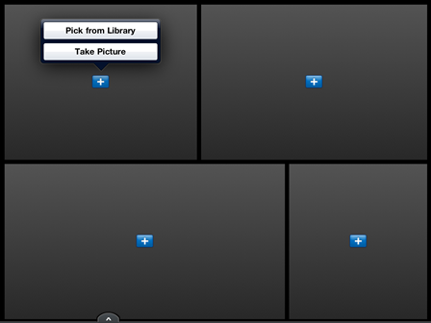
the page to select your template.

- Tap on a blue plus sign to add
a photo to your comic strip. You
can pick from the iPad photo
library or take a new photo.
- You can adjust the positioning of the photo by tapping on it and moving your finger.
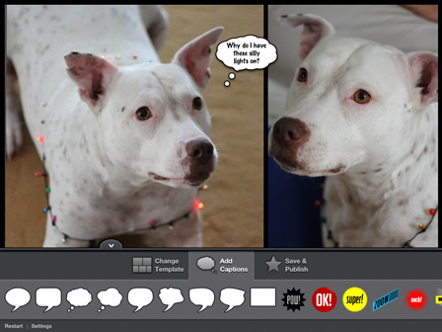
- Tap on ADD CAPTIONS to add speech bubbles and a limited range of stickers.

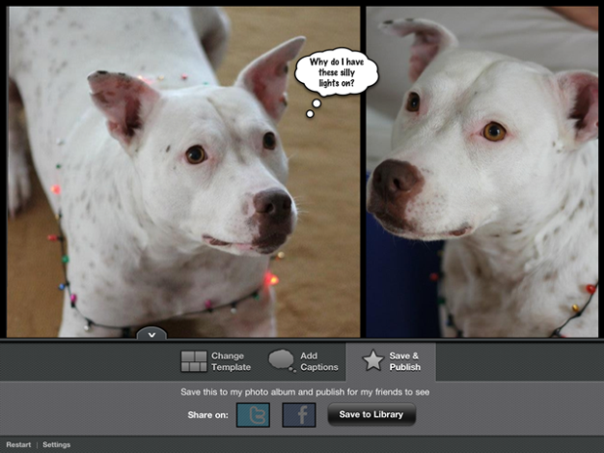
5. When you’re done, tap on SAVE & PUBLISH to save your image to the photo library. You can email it from there.

